STUDENT ID:22424424
library(MASS)
## Warning: package 'MASS' was built under R version 4.5.2
data("crabs")

QUESTION 1
##Data strucure and Group Composition
##Data strucure and Group Composition

##(a) describe the data set using the one in MASS
##(b) Load the data set and display its structure
##(c) Produce frequency tables for specific species and sex
##(d) Construct an appropriate bar chat or mosaic plot summarizing the composition
##(e) Comment on whether the dataset is balanced across the four groups

(a) MASS description
?crabs
## starting httpd help server ... done

(b) structure
str(crabs)
## 'data.frame': 200 obs. of 8 variables:
## $ sp : Factor w/ 2 levels "B","O": 1 1 1 1 1 1 1 1 1 1 ...
## $ sex : Factor w/ 2 levels "F","M": 2 2 2 2 2 2 2 2 2 2 ...
## $ index: int 1 2 3 4 5 6 7 8 9 10 ...
## $ FL : num 8.1 8.8 9.2 9.6 9.8 10.8 11.1 11.6 11.8 11.8 ...
## $ RW : num 6.7 7.7 7.8 7.9 8 9 9.9 9.1 9.6 10.5 ...
## $ CL : num 16.1 18.1 19 20.1 20.3 23 23.8 24.5 24.2 25.2 ...
## $ CW : num 19 20.8 22.4 23.1 23 26.5 27.1 28.4 27.8 29.3 ...
## $ BD : num 7 7.4 7.7 8.2 8.2 9.8 9.8 10.4 9.7 10.3 ...
summary(crabs)
## sp sex index FL RW CL
## B:100 F:100 Min. : 1.0 Min. : 7.20 Min. : 6.50 Min. :14.70
## O:100 M:100 1st Qu.:13.0 1st Qu.:12.90 1st Qu.:11.00 1st Qu.:27.27
## Median :25.5 Median :15.55 Median :12.80 Median :32.10
## Mean :25.5 Mean :15.58 Mean :12.74 Mean :32.11
## 3rd Qu.:38.0 3rd Qu.:18.05 3rd Qu.:14.30 3rd Qu.:37.23
## Max. :50.0 Max. :23.10 Max. :20.20 Max. :47.60
## CW BD
## Min. :17.10 Min. : 6.10
## 1st Qu.:31.50 1st Qu.:11.40
## Median :36.80 Median :13.90
## Mean :36.41 Mean :14.03
## 3rd Qu.:42.00 3rd Qu.:16.60
## Max. :54.60 Max. :21.60
head(crabs)
## sp sex index FL RW CL CW BD
## 1 B M 1 8.1 6.7 16.1 19.0 7.0
## 2 B M 2 8.8 7.7 18.1 20.8 7.4
## 3 B M 3 9.2 7.8 19.0 22.4 7.7
## 4 B M 4 9.6 7.9 20.1 23.1 8.2
## 5 B M 5 9.8 8.0 20.3 23.0 8.2
## 6 B M 6 10.8 9.0 23.0 26.5 9.8

(c) frequency tables
freq_species <- table(crabs$sp)
freq_sex <- table(crabs$sex)
tab_sp_sex <- table(Species = crabs$sp, Sex = crabs$sex)
freq_species
##
## B O
## 100 100
freq_sex
##
## F M
## 100 100
tab_sp_sex
## Sex
## Species F M
## B 50 50
## O 50 50
prop.table(tab_sp_sex)
## Sex
## Species F M
## B 0.25 0.25
## O 0.25 0.25
prop.table(tab_sp_sex, margin = 1)
## Sex
## Species F M
## B 0.5 0.5
## O 0.5 0.5
prop.table(tab_sp_sex, margin = 2)
## Sex
## Species F M
## B 0.5 0.5
## O 0.5 0.5

(d) barplots and mosaicplot
barplot(tab_sp_sex,
beside = FALSE,
col = c("skyblue","red"),
legend.text = TRUE,
xlab = "Species", ylab = "Count",
main = "Composition by Species and Sex (Stacked)")
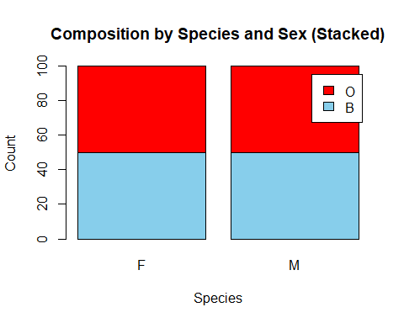
barplot(tab_sp_sex,
beside = TRUE,
col = c("skyblue","red"),
legend.text = TRUE,
xlab = "Species", ylab = "Count",
main = "Composition by Species and Sex (Beside)")
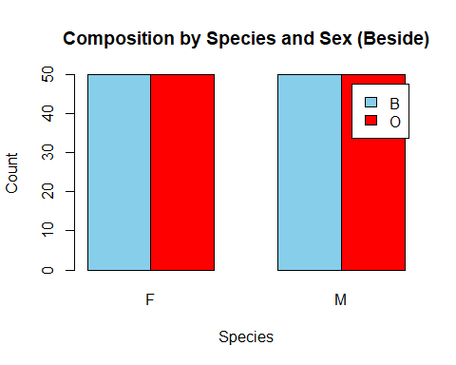
mosaicplot(tab_sp_sex,
color = c("skyblue","tomato"),
main = "Mosaic plot: Species vs Sex",
xlab = "Species", ylab = "Sex")
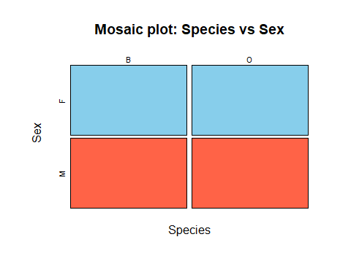

(e) balance across four groups
counts_4groups <- as.vector(tab_sp_sex)
min(counts_4groups)
## [1] 50
max(counts_4groups)
## [1] 50
min(counts_4groups) == max(counts_4groups)
## [1] TRUE
(e) COMMENT
the dataset is balanced across the four groups defined by species × sex. The two-way frequency table shows 50 crabs in each combination (B–F, B–M, O–F, O–M), and the balance check confirms the minimum and maximum group counts are both 50

QUESTION 2
##Distribution of Body Depth
##Distribution of Body Depth
##(a) Construct side-by side boxplot of a body deph(BD) for the four groups defined by species and sex
##(b) Identify any outliers and compare the central tendency and variability between groups

(a) Side-by-side boxplot of BD for 4 groups
group_4 <- interaction(crabs$sp, crabs$sex, sep = "_")
boxplot(BD ~ group_4, data = crabs,
col = c("gold","lightgreen","lightskyblue","plum"),
xlab = "Group (Species_Sex)", ylab = "Body Depth (BD)",
main = "BD by Species and Sex")
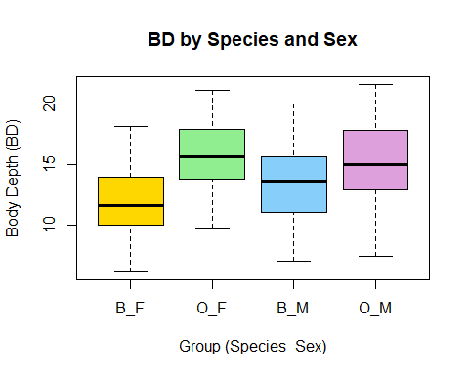

(b) Identify outliers
bp_bd <- boxplot(BD ~ group_4, data = crabs, plot = FALSE)
outliers_bd <- data.frame(group = bp_bd$names[bp_bd$group],
outlier_BD = bp_bd$out)
outliers_bd
## [1] group outlier_BD
## <0 rows> (or 0-length row.names)

Compare central tendency and variability (mean, median, SD, IQR)
bd_summary <- aggregate(crabs$BD, by = list(group = group_4),
FUN = function(x) c(mean = mean(x),
median = median(x),
sd = sd(x),
IQR = IQR(x)))
bd_summary_table <- data.frame(group = bd_summary$group, bd_summary$x)
names(bd_summary_table) <- c("group","mean","median","sd","IQR")
bd_summary_table
## group mean median sd IQR
## 1 B_F 11.816 11.60 2.752465 3.850
## 2 O_F 15.632 15.65 2.752620 4.050
## 3 B_M 13.350 13.60 3.199888 4.600
## 4 O_M 15.324 15.00 3.527187 4.825

QUESTION 3
##(a)produce histogram of carapace length (CL) for each species
##(b)Describe and compare the shapes of the distribution, commenting on the skewness and modality

(a) Histograms of CL for each species (WITH COLORS)
sp_levels <- levels(crabs$sp)
par(mfrow = c(1, 2))
hist(crabs$CL[crabs$sp == sp_levels[1]],
col = "skyblue",
border = "white",
main = paste("CL Histogram:", sp_levels[1]),
xlab = "Carapace Length (CL)")
hist(crabs$CL[crabs$sp == sp_levels[2]],
col = "red",
border = "white",
main = paste("CL Histogram:", sp_levels[2]),
xlab = "Carapace Length (CL)")
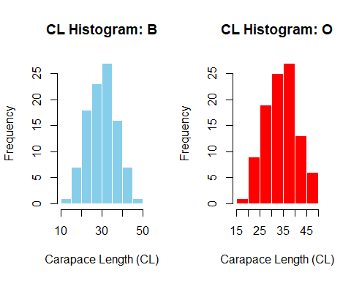
par(mfrow = c(1, 1))

(b) Describe shape support: summaries + skewness + density overla
by(crabs$CL, crabs$sp, summary)
## crabs$sp: B
## Min. 1st Qu. Median Mean 3rd Qu. Max.
## 14.70 24.85 30.10 30.06 34.60 47.10
## ------------------------------------------------------------
## crabs$sp: O
## Min. 1st Qu. Median Mean 3rd Qu. Max.
## 16.70 29.20 34.55 34.15 39.40 47.60
skewness <- function(x){
x <- x[is.finite(x)]
m <- mean(x); s <- sd(x)
mean(((x - m)/s)^3)
}
by(crabs$CL, crabs$sp, skewness)
## crabs$sp: B
## [1] 0.02571518
## ------------------------------------------------------------
## crabs$sp: O
## [1] -0.1536776
plot(density(crabs$CL[crabs$sp == sp_levels[1]]),
col = "skyblue", lwd = 2,
main = "Density of CL by Species",
xlab = "Carapace Length (CL)")
lines(density(crabs$CL[crabs$sp == sp_levels[2]]),
col = "red", lwd = 2)
legend("topright", legend = sp_levels,
col = c("skyblue","red"), lwd = 2, bty = "n")
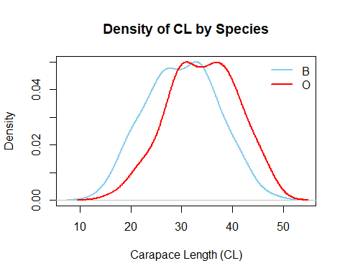

—————————-

QUESTION 4
##(a) Compute the mean of each morphological measurement (FL, RW,CL,CW,BD)
##(b) Construct a grouped bar chart to display these means
##(c) Identify which measurement shows the greatest species difference and which shows the least sex variation

(a) Mean of each morphological measurement (overall)
means_overall <- colMeans(crabs[, c("FL","RW","CL","CW","BD")])
means_overall
## FL RW CL CW BD
## 15.5830 12.7385 32.1055 36.4145 14.0305

(b) Grouped bar chart of means by Species and Sex (WITH COLORS)
means_by_sp_sex <- aggregate(crabs[, c("FL","RW","CL","CW","BD")],
by = list(Species = crabs$sp, Sex = crabs$sex),
FUN = mean)
group_labels <- paste(means_by_sp_sex$Species, means_by_sp_sex$Sex, sep = "_")
means_matrix <- t(as.matrix(means_by_sp_sex[, c("FL","RW","CL","CW","BD")]))
colnames(means_matrix) <- group_labels
barplot(means_matrix,
beside = TRUE,
col = c("gold","lightgreen","lightskyblue","red","purple"),
legend.text = rownames(means_matrix),
xlab = "Group (Species_Sex)", ylab = "Mean value",
main = "Mean Measurements by Species and Sex")
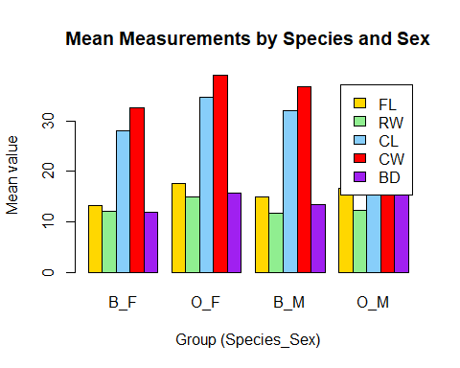

(c) Greatest species difference + least sex variation
means_by_species <- aggregate(crabs[, c("FL","RW","CL","CW","BD")],
by = list(Species = crabs$sp),
FUN = mean)
diff_species <- abs(as.numeric(means_by_species[1, -1]) - as.numeric(means_by_species[2, -1]))
names(diff_species) <- c("FL","RW","CL","CW","BD")
diff_species
## FL RW CL CW BD
## 3.054 1.621 4.095 3.395 2.895
greatest_species_difference <- names(which.max(diff_species))
greatest_species_difference
## [1] "CL"
means_by_sex <- aggregate(crabs[, c("FL","RW","CL","CW","BD")],
by = list(Sex = crabs$sex),
FUN = mean)
diff_sex <- abs(as.numeric(means_by_sex[1, -1]) - as.numeric(means_by_sex[2, -1]))
names(diff_sex) <- c("FL","RW","CL","CW","BD")
diff_sex
## FL RW CL CW BD
## 0.302 1.497 1.491 1.169 0.613
least_sex_variation <- names(which.min(diff_sex))
least_sex_variation
## [1] "FL"

—————————-

QUESTION 5
##(a)produce a scatter matrix(pair plot ) of five measurement
##(b) describe the strength and nature of the relationships among variables

# (a) Scatter matrix (pair plot)

(a) Scatter matrix (pair plot) WITH COLORS (by species)
sp_colors <- ifelse(crabs$sp == sp_levels[1], "green", "red")
pairs(crabs[, c("FL","RW","CL","CW","BD")],
col = sp_colors,
pch = 16,
main = "Scatter Matrix of Measurements (colored by Species)")
legend("topright", legend = sp_levels,
col = c("green","red"), pch = 16, bty = "n")
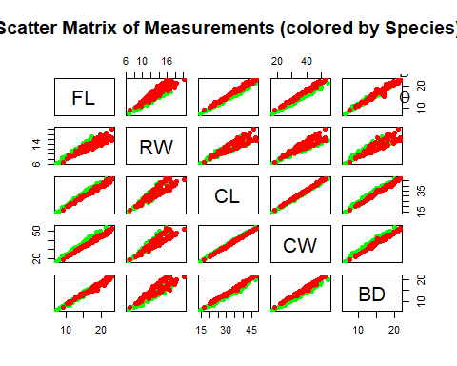
# (b) Strength/nature of relationships: correlation matrix
cor(crabs[, c("FL","RW","CL","CW","BD")])
## FL RW CL CW BD
## FL 1.0000000 0.9069876 0.9788418 0.9649558 0.9876272
## RW 0.9069876 1.0000000 0.8927430 0.9004021 0.8892054
## CL 0.9788418 0.8927430 1.0000000 0.9950225 0.9832038
## CW 0.9649558 0.9004021 0.9950225 1.0000000 0.9678117
## BD 0.9876272 0.8892054 0.9832038 0.9678117 1.0000000

QUESTION 6
STATISTICAL REPORT
The 200 crabs in the MASS dataset "crabs" have five continuous morphological variables (FL, RW, CL, CW, BD) and two categorical grouping variables: species (B, O) and sex (F, M). The summary function call indicates that the sizes are clustered around FL ≈ 15.58, RW ≈ 12.74, CL ≈ 32.11, CW ≈ 36.41, and BD ≈ 14.03. The structure function call confirms that there are eight variables in total, including an index.

This dataset's excellent balance is one of its main advantages. The frequency tables, which indicate that there are 100 crabs for each species, 100 for each sex, and precisely 50 for each of the four species-sex combinations (B_F, B_M, O_F, O_M), make this clear. The balancing check, which has a minimum and maximum of 50 groups, makes this clear as well. The equal representation of each group is further supported by the bar plots and mosaic plot, which ensure that any discrepancies discovered later are not the result of variations in sample numbers.
This dataset's excellent balance is one of its main advantages. The frequency tables, which indicate that there are 100 crabs for each species, 100 for each sex, and precisely 50 for each of the four species-sex combinations (B_F, B_M, O_F, O_M), make this clear. The balancing check, which has a minimum and maximum of 50 groups, makes this clear as well. The equal representation of each group is further supported by the bar plots and mosaic plot, which ensure that any discrepancies discovered later are not the result of variations in sample numbers.

The histograms and density plots show that species O typically has bigger values of carapace length (CL) than species B (means of 34.15 vs. 30.06, medians of 34.55 vs. 30.10). The two species are roughly unimodal. The species have near-zero skewness values, with B being 0.026 (very slight right skew) and O being -0.154 (slight left skew); hence, the primary difference is in location (typical size), not in shape
The bar chart of grouped means shows that species differences are typically larger than sex differences when comparing mean morphology on the five measurements. Carapace length is the most crucial metric for differentiating between the two species in this analysis, as evidenced by the fact that CL (4.095) has the largest absolute difference between species. The frontal lobe size is the measurement that varies the least between the sexes, as evidenced by the fact that the variances between the sexes are the smallest for FL (0.302).
Finally, multivariate analysis utilizing the correlation matrix and scatterplot matrix shows that all five measurements have substantial positive correlations, which is to be expected given the presence of a strong "overall size" factor. In particular, every correlation is high, ranging from roughly 0.889 to 0.995. CL and CW have the strongest association (r = 0.995), indicating a tendency for these two dimensions to grow proportionately. In line with earlier observations that species O tends to be larger on important dimensions, the scatter matrix, colored by species, shows that the two species overlap but tend to occupy slightly distinct locations.

